Extended-Abstract Template (Times New Roman 14 PT, Bold)

A.B. Yue¹, C.D. Keer*² and E. Lau^{#1}
¹Department of ABC, University of XXX, City, Country
²Department of IJK, University of YYY, City, Country

*Corresponding author: xxx@yyy.zzz
# Presenter: aaa@bbb.ccc

Authors should submit an extended-abstract written in English including supporting figures, within one A4 page with one inch margins. Times New Roman 12 pt shall be used.
Please follow font types, styles and sizes as in this template. A figure caption should be inserted below the figure. Authors are reminded to ensure the resolution of figures to be high enough. Please try to modify this template to form your submission.
Please send the completed registration form to Ms. Bridget Lam at igscsrm@hku.hk as soon as possible (HKU will send you the invitation letter for VISA application). Please send the extended-abstract together on or before the due date.

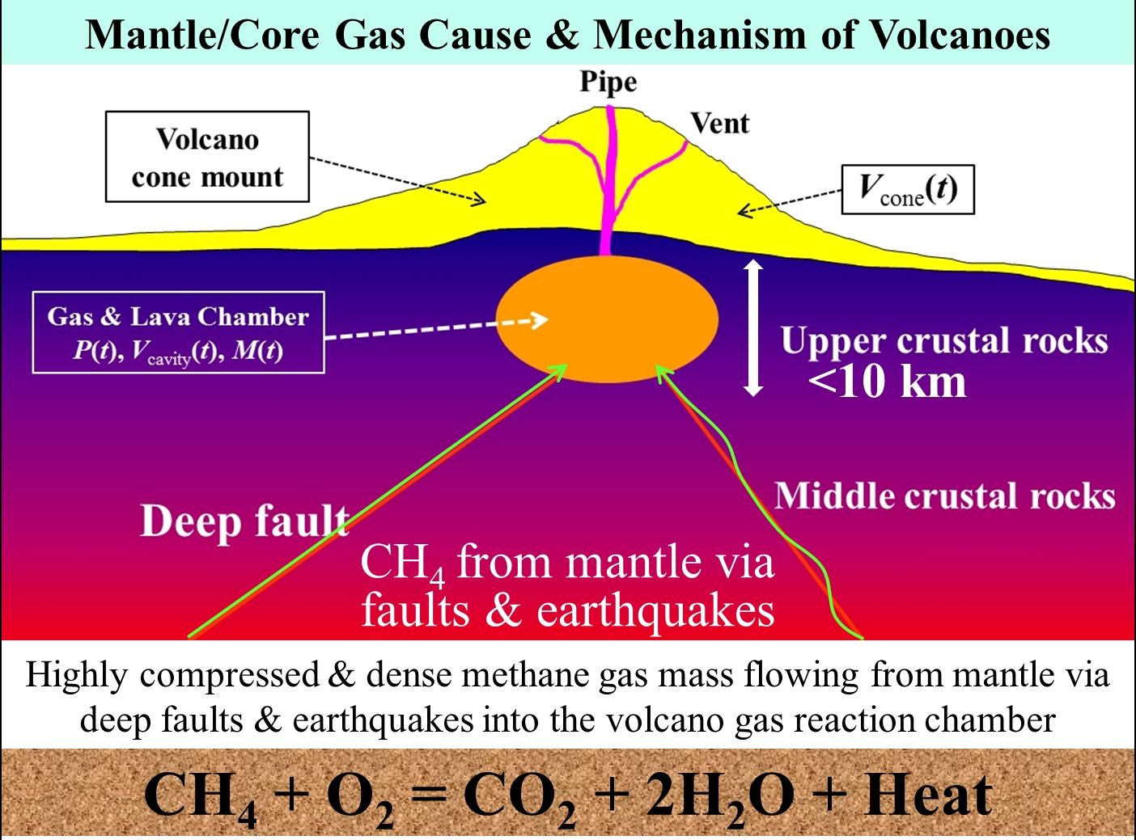
Figure 1. A sample of a figure (the caption is in Times New Roman 10 pt).

Acknowledgements
The authors wish to thank …. (in Times New Roman 12 pt). This section is optional.

References (in Times New Roman 10 pt)
Xiao HT, Yue ZQ, 2014. Fracture Mechanics in Layered and Graded Solids: Analysis Using Boundary Element Methods, De Gruyter & Higher Education Press, Berlin, Germany.
Yue ZQ, 2014. On cause hypotheses of earthquakes with external tectonic plate and/or internal dense gas loadings, Acta Mechnica, 225(4), 1447–1469.
Yue ZQ, 2015. Migration and expansion of highly compressed gas from deep ground for cause of large rock avalanches, ISRM Congress 2015 Proceedings - Int’l Symposium on Rock Mechanics - ISBN: 978-1-926872-25-4, Montreal, Canada, Paper No. 106.

